**An Internship Report**

**On**

**Salesforce AI Developer Virtual Internship**

**Submitted In accordance with the requirement for the degree of**

**BACHELOR OF TECHNOLOGY**

**INFORMATION TECHNOLOGY**

**Submitted by**

**Papana Sudheer (218X1A1225)**

**Katteboina Sasi Vardhan (218X1A1216)**

**Ganji Kiran Reddy (218X1A1252)**



**DEPARTMENT OF INFORMATION TECHNOLOGY**

**KALLAM HARANADHAREDDY INSTITUTE OF TECHNOLOGY  
(AUTONOMOUS)**

**Approved by (AICTE, New Delhi; Permanently Affiliated to JNTU KAKINADA)**

**Accredited by NAAC with an ‘A’ Grade**

**NH – 16, Chowdavaram, Guntur – 522019 (A.P)**

**ACADEMIC YEAR: 2024-2025**

**Project Title :A CRM APPLICATION FOR LAPTOP RENTALS**

**Project Overview** : The CRM application for laptop rentals is designed to streamline and optimize the entire rental process for a laptop rental business. It will feature comprehensive customer management tools, allowing for the creation, editing, and tracking of customer profiles, rental histories, and communications. The application will also include a robust inventory management system to track available laptops, their specifications, rental rates, and conditions, alongside the ability to record and manage rental transactions, including due dates, payment status, and invoicing. Customers will be able to book laptops online, with a booking system integrated into the platform, while administrators can manage maintenance schedules for laptops requiring repairs.

**SalesforceIntroduction:**  
  
Are you new to Salesforce? Not sure exactly what it is, or how to use it? Don’t know where you should start on your learning journey? If you’ve answered yes to any of these questions, then you’re in the right place. This module is for you.

Welcome to Salesforce! Salesforce is game-changing technology, with a host of productivity-boosting features, that will help you sell smarter and faster. As you work toward your badge for this module, we’ll take you through these features and answer the question, “What is Salesforce, anyway?”.

**What Is Salesforce?**

Salesforce is your customer success platform, designed to help you sell, service, market, analyze, and connect with your customers.

Salesforce has everything you need to run your business from anywhere. Using standard products and features, you can manage relationships with prospects and customers, collaborate and engage with employees and partners, and store your data securely in the cloud.

**Objectives:**

**Business goals:** The primary business goal of implementing a CRM application for laptop rentals is to enhance operational efficiency and profitability. By streamlining the rental process, the application aims to reduce administrative overhead, minimize errors, and optimize inventory utilization. This will lead to cost savings and increased revenue through better resource management. Additionally, the application seeks to improve customer satisfaction by providing a seamless booking experience, timely notifications, and personalized interactions. Enhanced customer relationships are expected to result in higher customer retention rates and increased repeat business.

**Expected outcome :** The expected output includes a significant reduction in the time required to manage rentals, from booking to return, thereby improving overall service delivery. The application will provide real-time inventory tracking, ensuring that laptops are always available for rent and reducing downtime. Automated billing and payment tracking will streamline financial processes, leading to more accurate and timely revenue collection. Detailed reports and dashboards will offer valuable insights into rental trends, customer preferences, and financial performance, enabling data-driven decision making. Ultimately, the CRM application will contribute to a more organized, efficient, and customer-centric rental operation, driving business growth and success.

**Key Features**

* **Device Inventory Management**: Easily add, update, and manage laptops in the inventory. Store comprehensive details like model, specifications, rental price, and availability status.
* **Rental and Return Tracking**: Monitor rental status, including duration, due dates, and overdue alerts. Simplify the return process by updating availability and recording return dates.
* **Customer Management**: Store customer information such as name, contact details, rental history, and preferences. Record all interactions, including communications and feedback.
* **Booking Process**: Facilitate the entire booking process, from reservation to completion, with availability checks and confirmation emails. Prevent double bookings to improve customer satisfaction.
* **Billing and Payment**: Automatically generate invoices based on rental duration and pricing rules. Track payments received and pending, and send reminders for overdue payments.
* **User Roles and Profiles**: Define different access levels for users like owners, managers, and agents to ensure data security and appropriate permissions.
* **Validation Rules**: Ensure data accuracy by implementing validation rules for critical fields such as phone number and email.
* **Automation**: Automate key processes like laptop distribution, rental extensions, and billing using Salesforce Flows and Apex triggers.
* **Reports and Dashboards**: Generate detailed reports on device utilization, rental durations, customer preferences, and financial performance. Provide customizable dashboards for real-time insights.
* **Notifications and Alerts**: Send automated notifications to customers for booking confirmations, due dates, and overdue alerts. Notify staff about important events like low inventory levels and upcoming maintenance.

**Milestone 1:**Creating Developer Account

**Creating a developer org in salesforce.**

1. **Go to**[**https://developer.salesforce.com/signup**](https://developer.salesforce.com/signup)
2. **On the sign up form, enter the following details :**

**[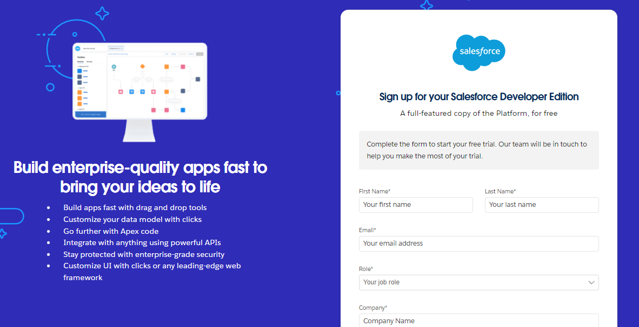](https://developers.salesforce.com/Signup*)**

**Then Fill the Details**

1. **First name & Last name :** batch15 Sudheer
2. **Email :**218x1a1225@khitguntur.ac.in
3. **Role :**Developer
4. **Company :**KHIT
5. **County :**India
6. **Postal Code :**522005
7. **Username :**batch15@lapirentals.com

**Account Activation**

1. Go to the inbox of the email that you used while signing up. Click on the verify account to activate your account. The email may take 5-10mins.

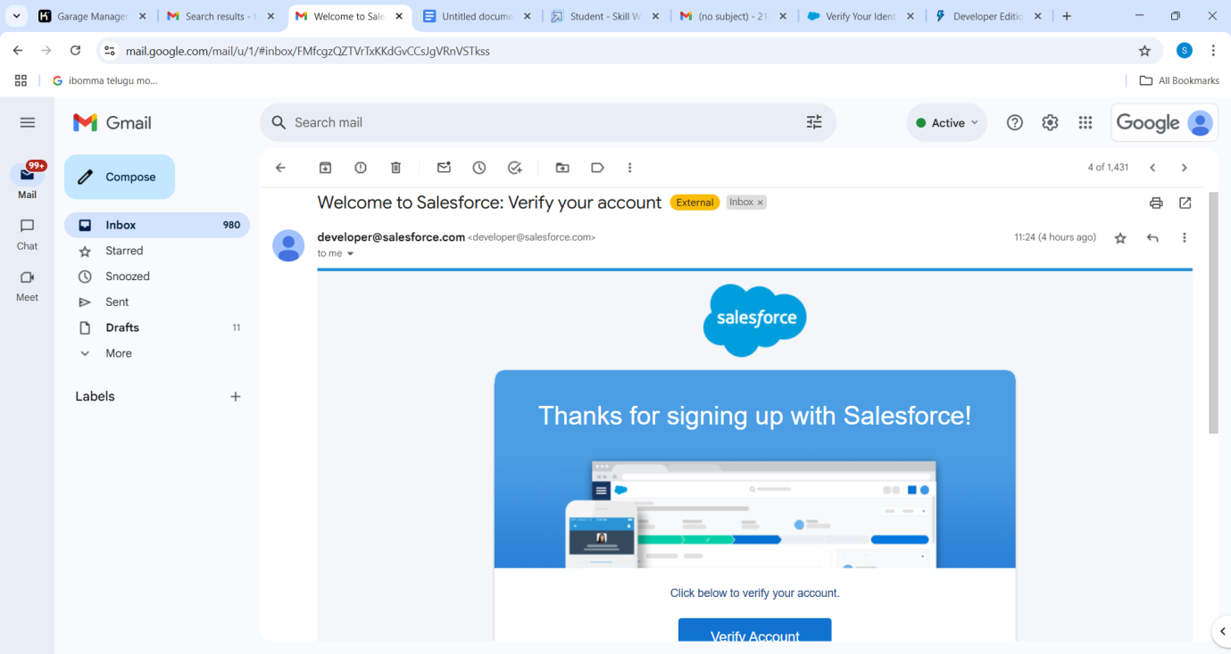

1. Click on Verify Account
2. Give a password and answer a security question and click on change password.

**Milestone 2 :Create Total Laptops Object**

1. From the setup page >> Click on Object Manager >> Click on Create >> Click on Custom Object.

1) Enter the label name>> Total Laptops

2) Plural label name>> Total Laptops

3) Enter Record Name Label and Format

   Record Name >>Total Laptops

    Data Type >> Text

1. Click on Allow reports,Allow search  and Track Field History,
2. Allow search >> Save.

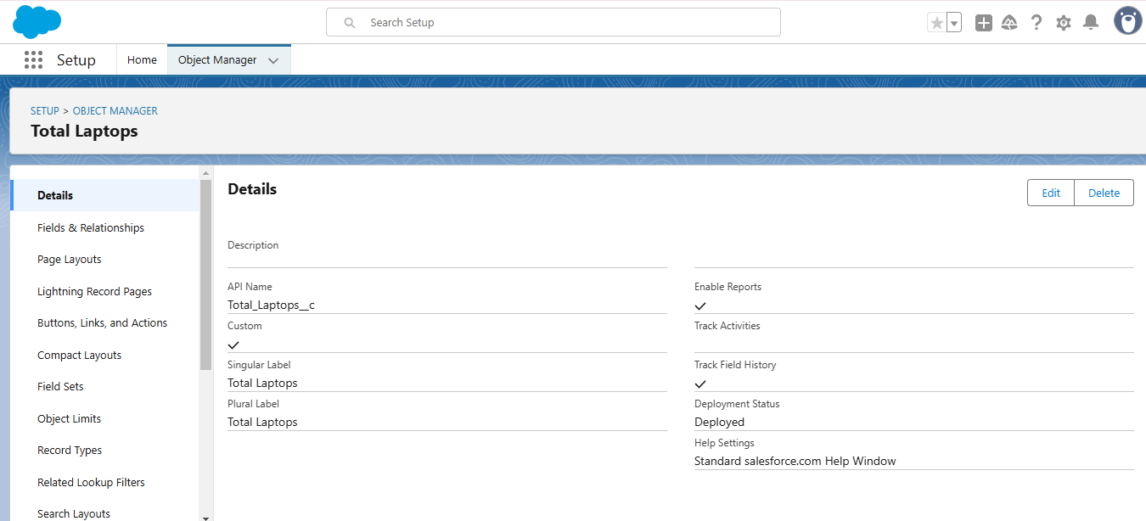

**Create Consumer Object**

To create an object:

From the setup page >> Click on Object Manager >> Click on Create >> Click on Custom Object.

1) Enter the label name >> consumer

2) Plural label name >> consumer

3) Enter Record Name Label and Format

     Record Name >> consumer_name

     Data Type >> Name

1. Click on Allow reports,Allow search and Track Field History,
2. Allow search >> Save.

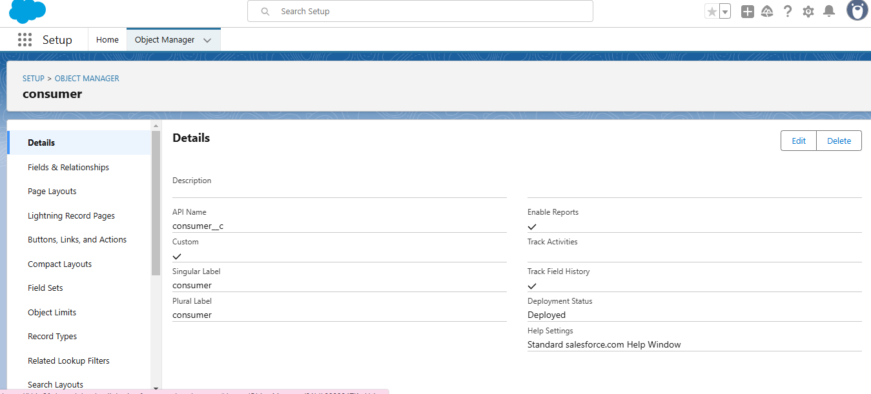

**Create Laptop Booking Object**

To create an object:

From the setup page >> Click on Object Manager >> Click on Create >> Click on Custom Object.

1) Enter the label name >> Laptop Bookings

2) Plural label name >> Laptop Bookings

3) Enter Record Name Label and Format

     Record Name >>  Laptop Bookings

      Data Type >> Name

1. Click on Allow reports,Allow search and Track Field History,
2. Allow search >> Save.

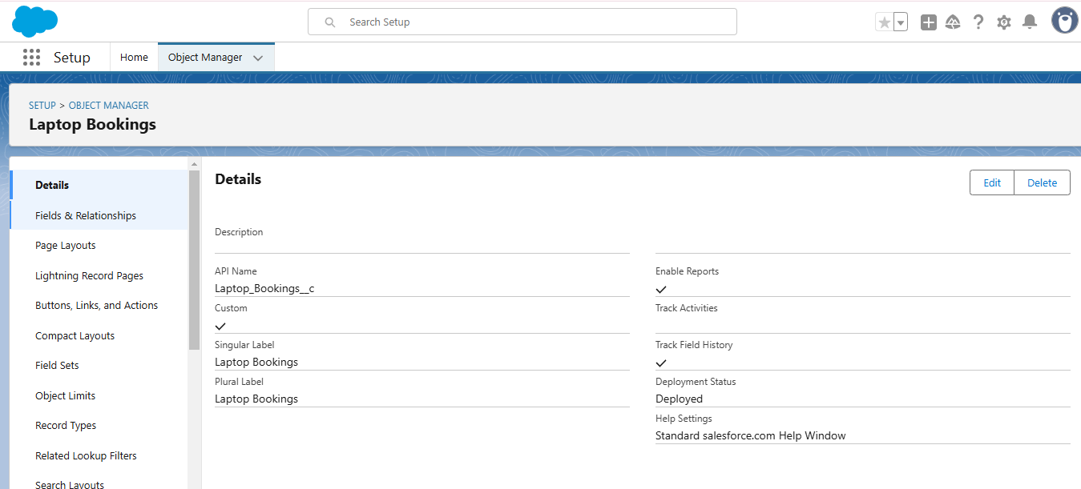

**Create Billing Process Object**

To create an object:

From the setup page >> Click on Object Manager >> Click on Create >> Click on Custom Object.

1) Enter the label name >> Billing Process

2) Plural label name >> Billing Process

3) Enter Record Name Label and Format

      Record Name >> Billing ProcessName

      Data Type >> Name

1. Click on Allow reports,Allow search and Track Field History,
2. Allow search >> Save.

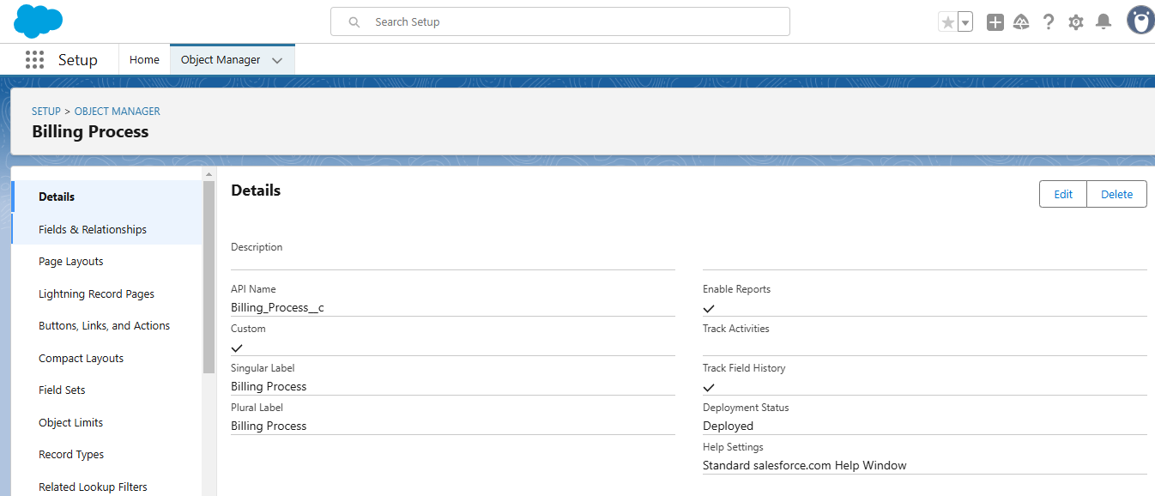

**Milestone 3 :**Tabs

**Creating a Custom Tab**

To create a Tab:(Customer Details)

1. Go to setup page >> type Tabs in Quick Find bar >> click on tabs >> New (under custom object tab)
2. Select Object(Total Laptops) >> Select the tab style >> Next (Add to profiles page) keep it as default >> Next (Add to Custom App)  uncheck the include tab .
3. Make sure that the Append tab to users' existing personal customizations is checked.
4. Click save.

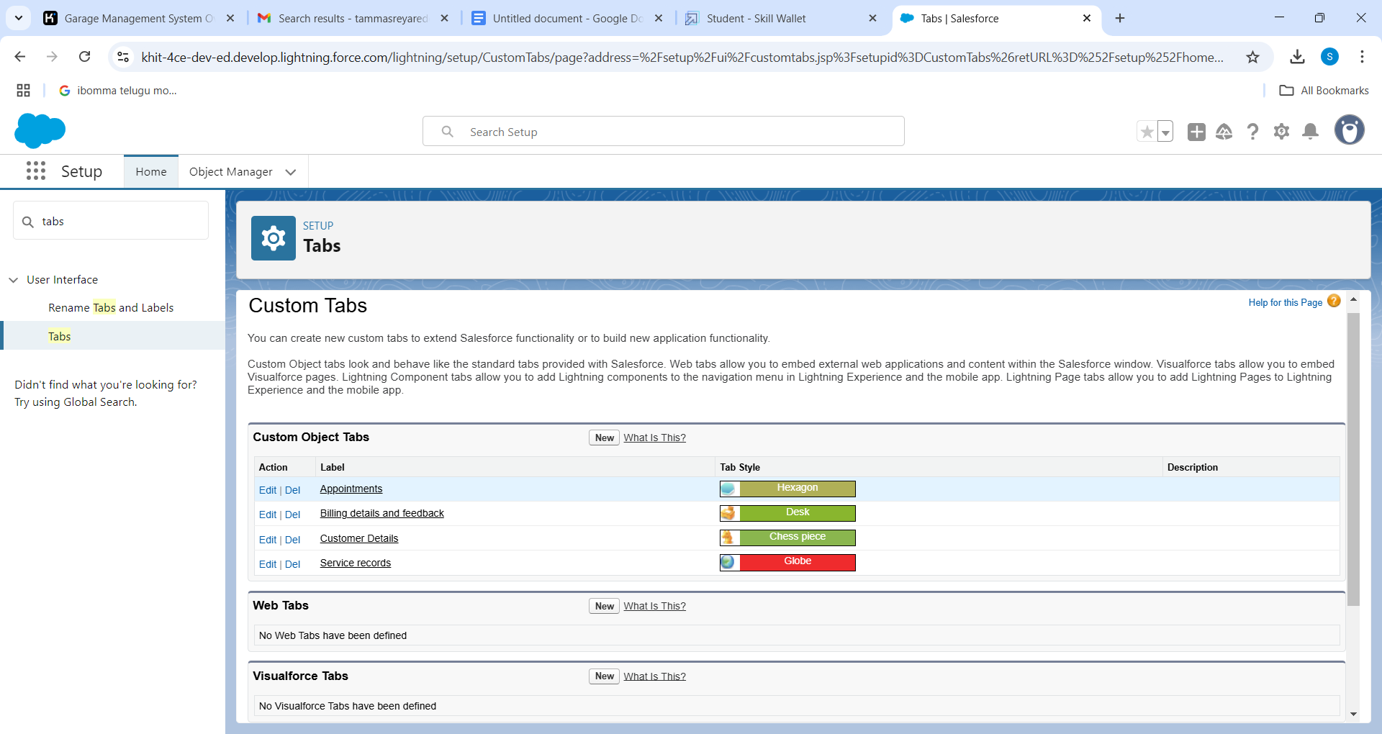

**Creating Remaining Tabs**

1. Now create the Tabs for the remaining Objects, they are “consumer,Laptop Booking,Billing process”.
2. Follow the same steps as mentioned in Activity -1

**Milestone 4 :**The Lightning App

To create a lightning app page:

1. Go to setup page >> search “app manager” in quick find >> select “app manager” >> click on New lightning App.
2. Fill the app name in app details as LAPTOP RENTALS >>Next  >> (App option page) keep it as default >> Next >> (Utility Items) keep it as default >> Next..
3. To Add Navigation Items:
4. Select the items (Total Laptops,consumer,Laptop Booking,Billing Process) from the search bar and move it using the arrow button >> Next
5. To Add User Profiles

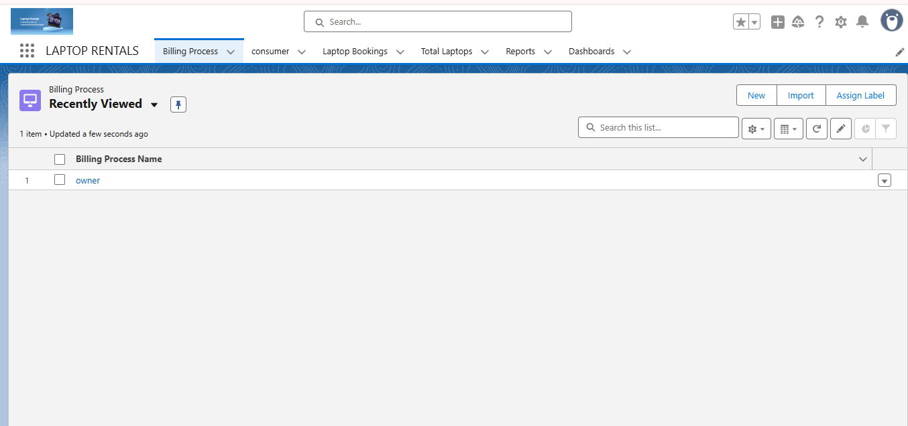

**Milestone 5 :**Fields

**Creation of fields for the Consumer object**

To create fields in an object:

1. Go to setup >> click on Object Manager >> type object name(consumer) in search bar >> click on the object.
2. Now click on “Fields & Relationships” >> New
3. Select Data Type as a “Phone”
4. Click on next
5. Fill the Above as following:

Field Label: Phone number

Field Name : gets auto generated

Click the required option checkbox.

Click on Next >> Next >> Save and new.

Note: Follow the above steps for the remaining field for the same object.

* To create another fields in an object:

1. Go to setup >> click on Object Manager >> type object name(consumer) in search bar >> click on the object.
2. Now click on “Fields & Relationships” >> New
3. Select Data type as a “Text Area” and Click on Next
4. Fill the Above as following:

* Field Label:  Address
* Field Name : It’s gets auto generated
* Select Required field.
* Click on Next >> Next >> Save and new.

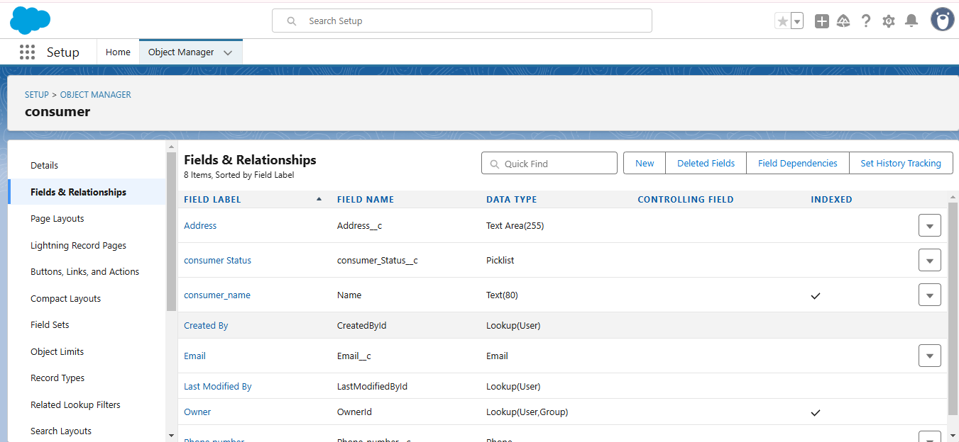

**Creation of Laptop Names Field on Appointment Object :**

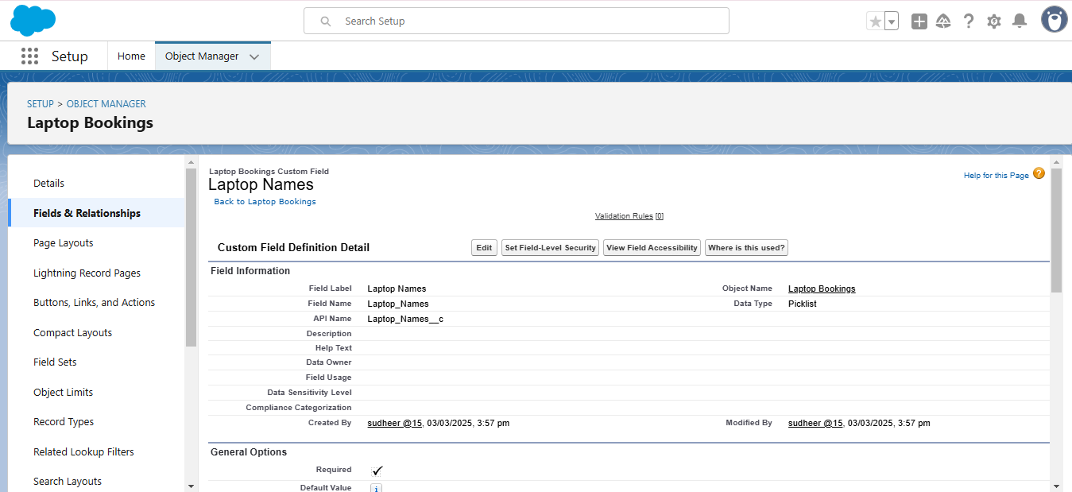

**Creation of Formula Field on Total Laptops Object :**

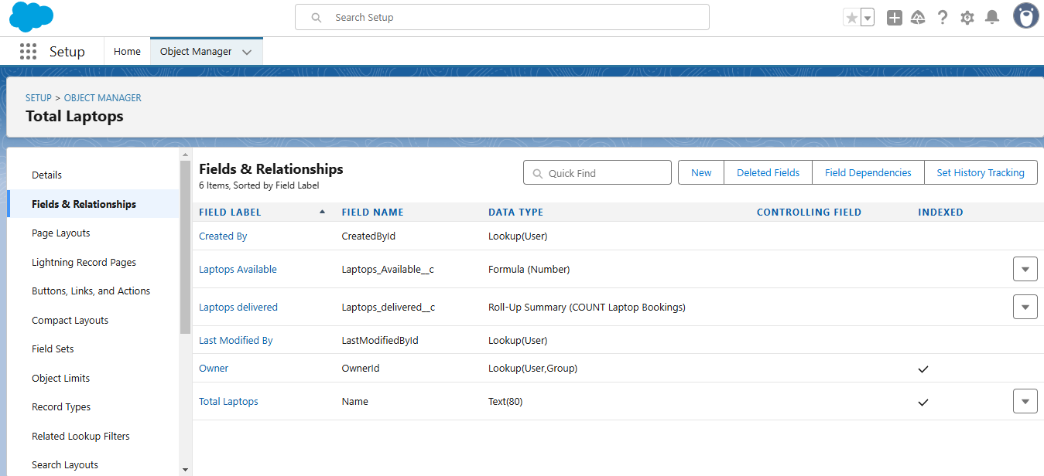

**Milestone 6 :**Validation rule

**To create a validation rule to an Appointment Object**

1. Go to the setup page >> click on object manager >> From drop down click edit for  consumer  object.
2. Click on the validation rule >> click New.
3. Enter the Rule name as “Phonenumberoremailblankrule ”.
4. Enter the description as “phone number and email number should not be blank”.
5. Enter the formula as “OR( ISBLANK( phone_number__c ) , ISBLANK( email__c ) )” and check the syntax.

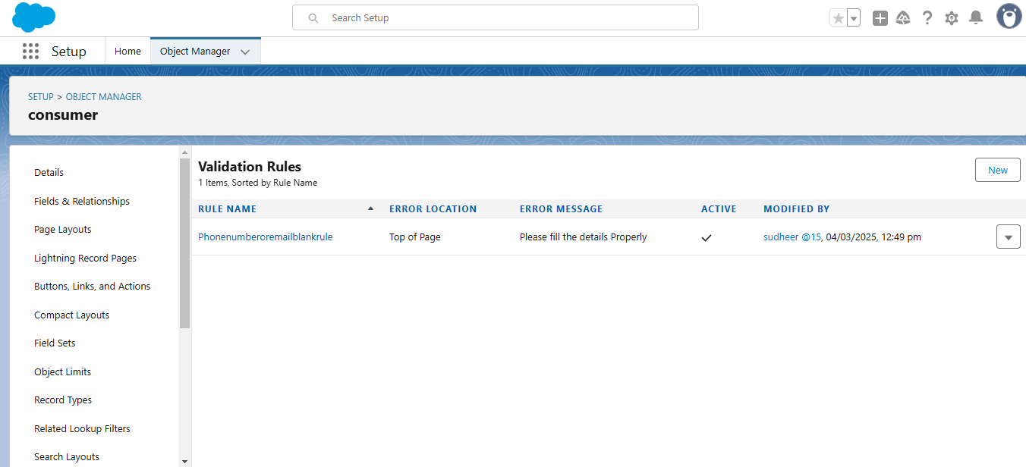

**Milestone 8 :**Profiles

**Owner Profile**

To create a new profile:

1. Go to setup >>  type profiles in quick find box  >>  click on profiles  >>  clone the desired profile (Standard User)  >>  enter profile name (Manager)  >>  Save.
2. Scroll down to Custom Object Permissions and Give access permissions for Total Laptops,   consumers , Laptop Booking and Billing Process  objects as mentioned in the below diagram.
3. Give Access and save it.

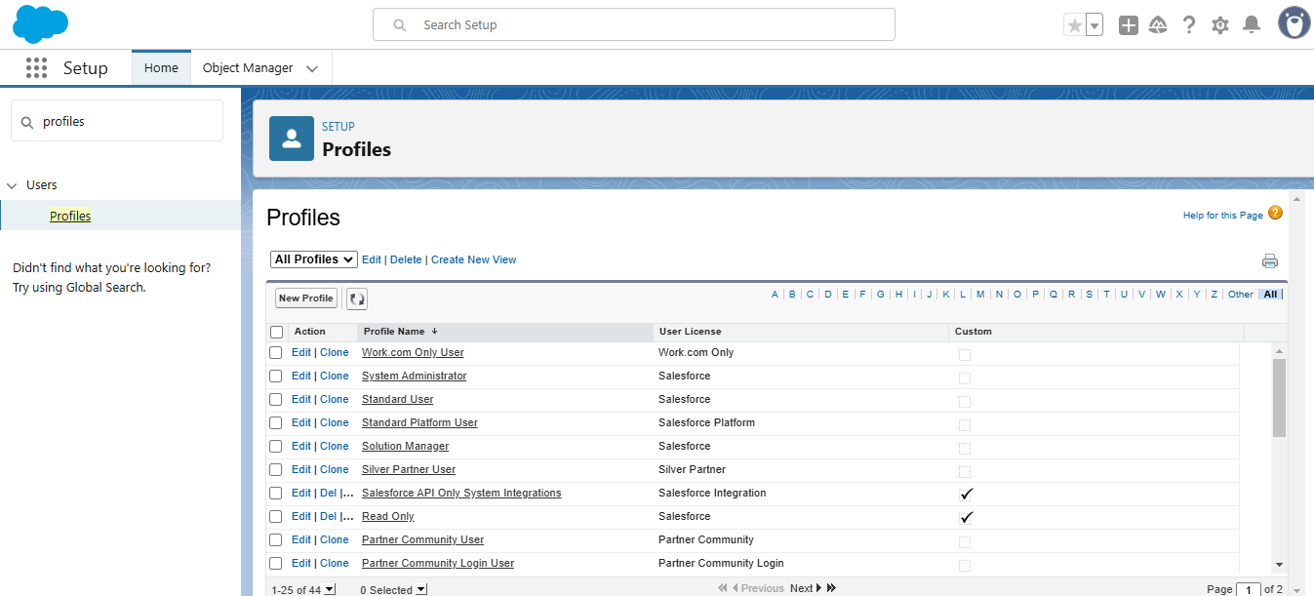

**Agent Profile**

1. Go to setup >> type profiles in quick find box >> click on profiles >> clone the desired profile (Standard Platform User) >> enter profile name (Agent) >>Save.
2. While still on the profile page, then click Edit.
3. Scroll down to Custom Object Permissions and Give access permissions for Total Laptops, consumer , Laptop Bookings  and Billing Process  objects as mentioned in the below diagram.

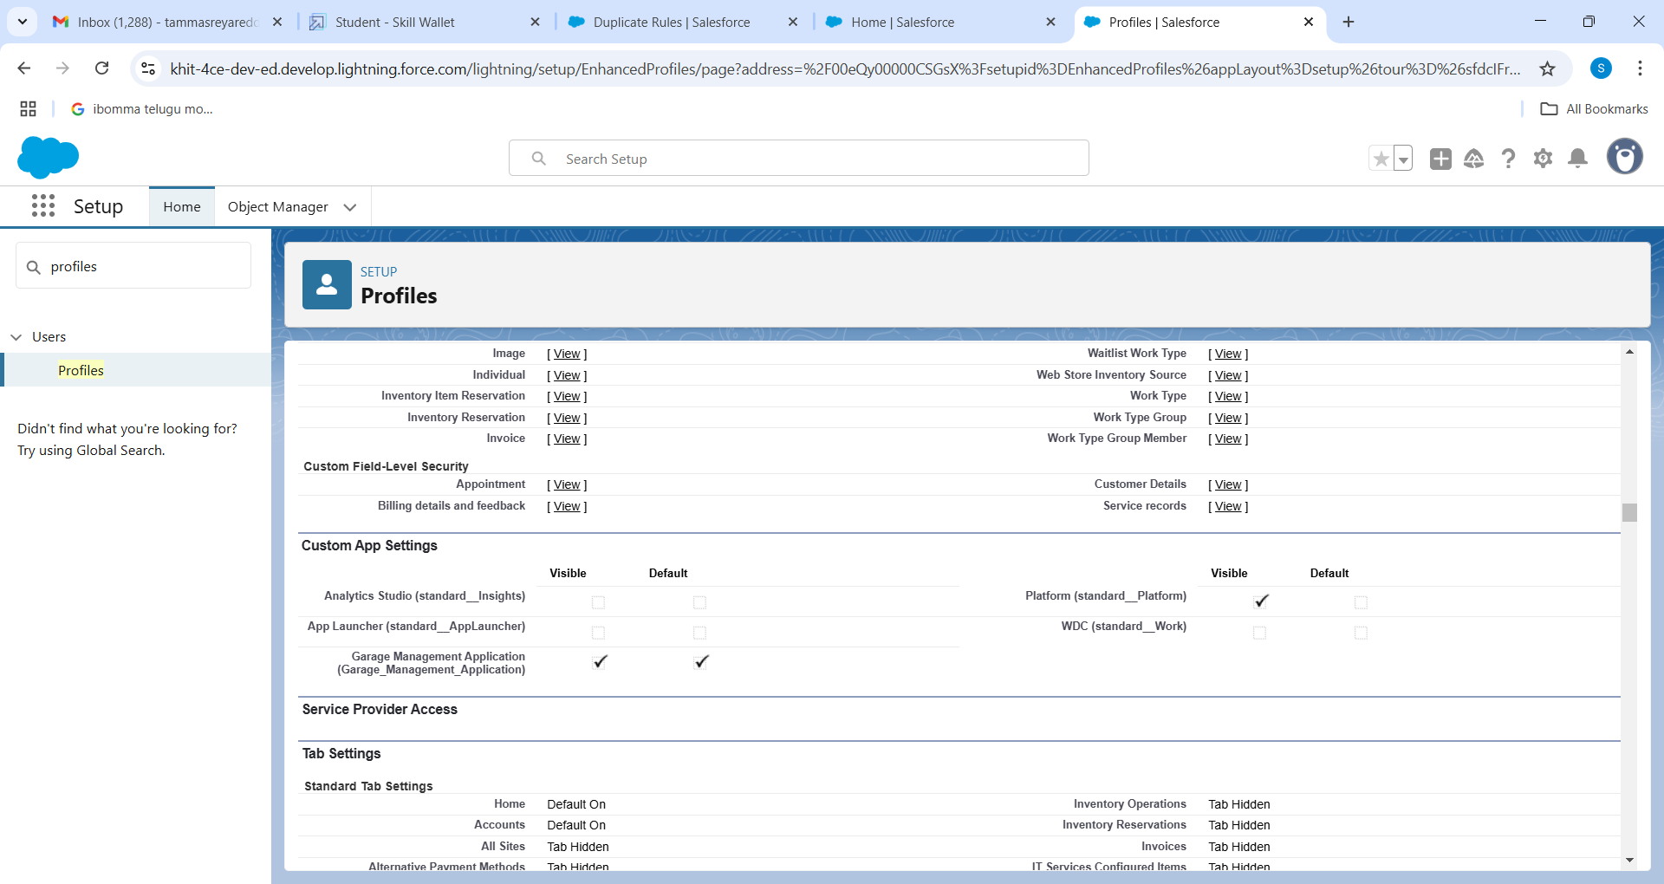

**Milestone 9 :**Role & Role Hierarchy

**Creating Manager Role:**

1. Go to quick find  >>  Search for Roles  >>  click on set up roles.

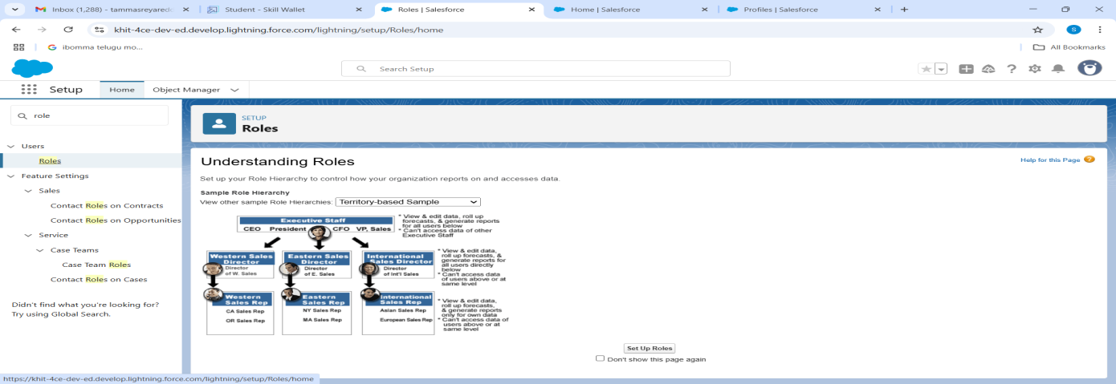

1. Click on Expand All and click on add role under whom this role works.

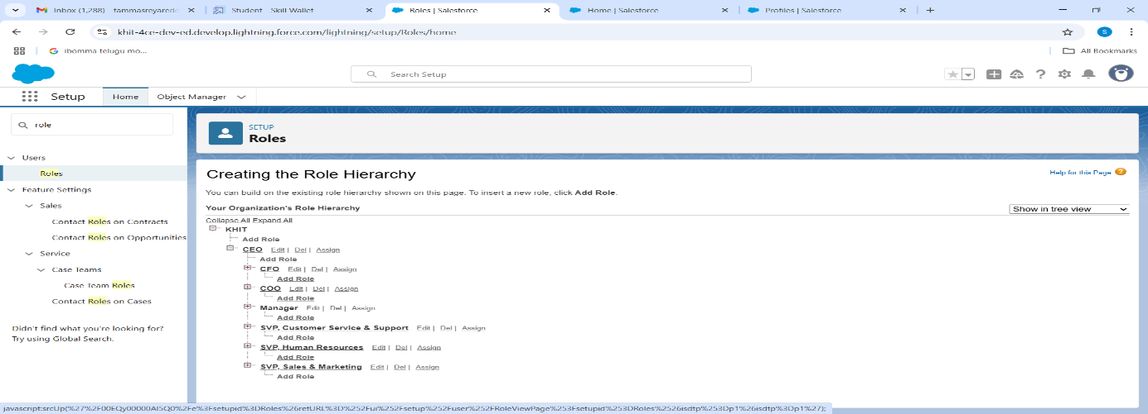

1. Give Label as “Owner” and Role name gets auto populated. Then click on Save.

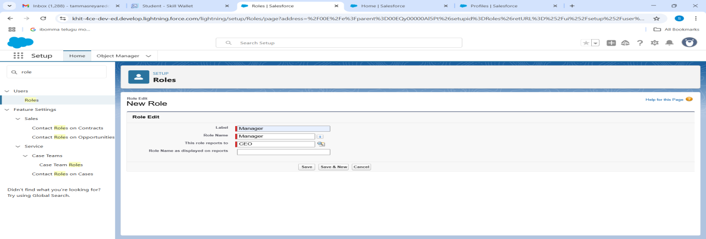

**Creating another roles**

1. Creating another two roles under Owner
2. Go to quick find  >>  Search for Roles  >>  click on set up roles.
3. Click plus on CEO role, and click add role under manager.
4. Give Label as “Agent” and Role name gets auto populated. Then click on Save.

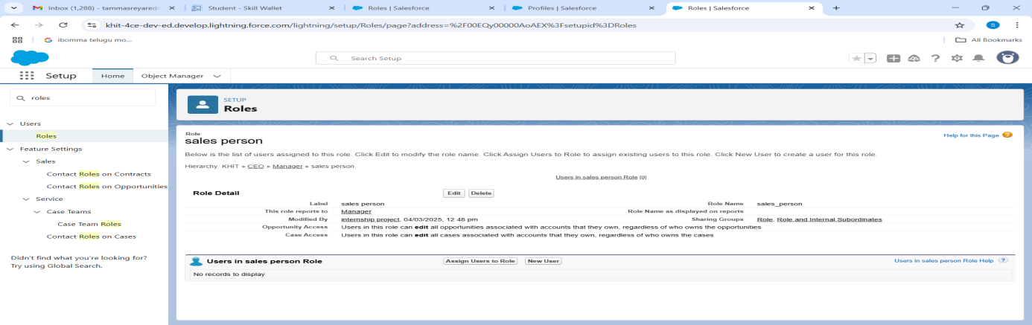

**Milestone 10 :**Users

**Create User**

1. Go to setup - type users in quick find box - select users -click New user.
2. Fill in the fields
3. First Name : vicky
4. Last Name : y
5. Alias : Give a Alias Name
6. Email id : Give your Personal Email id
7. Username : Username should be in this form: text@text.text
8. Nick Name : Give a Nickname
9. Role : owner
10. User license : Salesforce
11. Profiles : owner.

Save it.

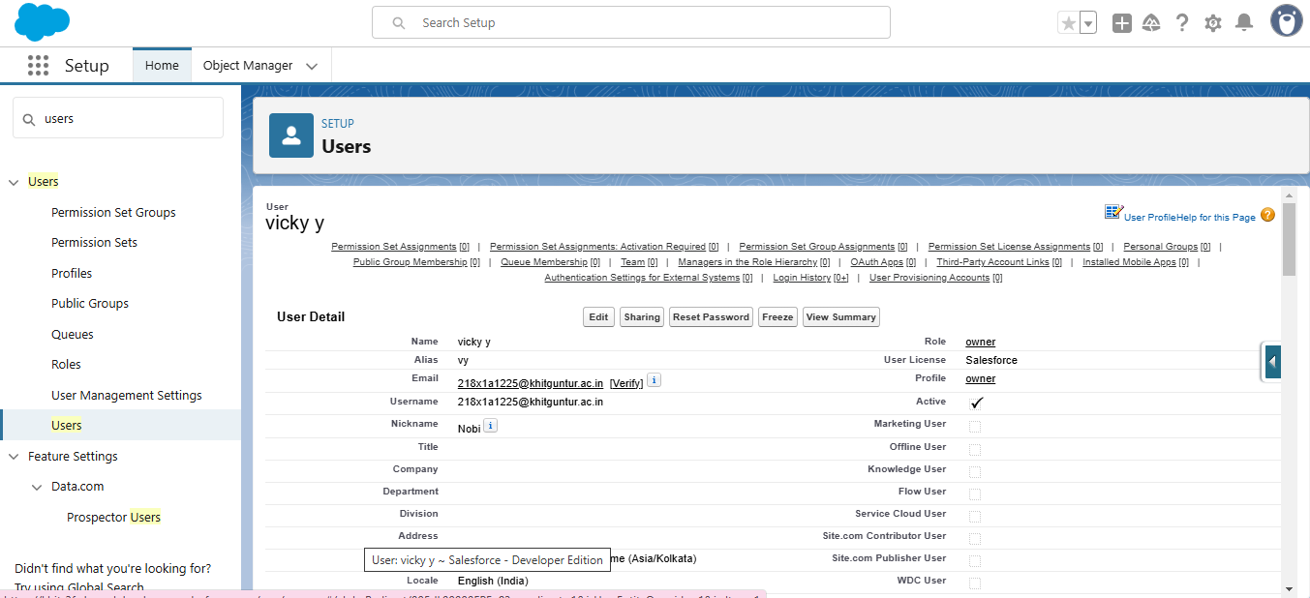

### **Milestone 11 :** Create a Flow on dell laptop

1.Go to setup >>type Flow in quick find box >> Click on the Flow and Select the New Flow

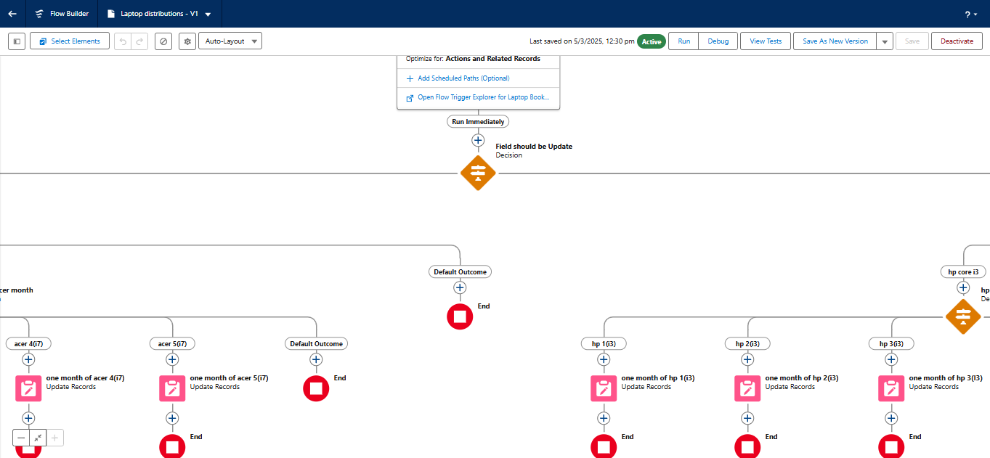

2.Select the Record-triggered flow and Click on Create.

3.Select the Object as a Laptop  Booking in the Drop down list.

4.Select the Trigger Flow when: “A record is Created or Updated”.

5.Select the Optimize the flow for: “Actions and Related Records” and Click on Done.

6.Under the Record-triggered Flow Click on “+” Symbol and In the Drop down List select the “Decision Element

7.Enter the Details Label: Field should be Update, API name: Gets Automatically Generated.

8.Enter the Outcome Details Label: dell , Outcome API name: Gets Automatically Generated.

* Resource: Select $Record.Laptop_name__c.
* Operator: Select Equals.
* Value: Select dell
* Add the same outcome order  to acer , hp, mac.
* Rename Default outcome as False
* Click done.

**To Create Flow On Acer Laptop**

1. Go to flow page
2. Beside  acer  there is a symbol   ‘+’   click on that.
3. Again select decision
4. Enter the Details Label: Acer core type selection, API name: Gets Automatically Generated.
5. Select the Outcome Details Label: acer core i3 , Outcome API name: Gets Automatically Generated.
   * Resource:   Select Record.core type.
   * Operator:   Select Equals.
   * Value: Select core i3.
6. Similarly create outcomes for acer core i5 and acer core i7 also.
7. Beside  dell there is a symbol   ‘+’   click on that.
8. Again select decision
9. Enter the Details Label: Acer months selected , API name: Gets Automatically Generated.
10. Enter the Outcome Details Label: acer 1(i3) , Outcome API name: Gets Automatically Generated.
11. Resource: Select Record.how many months.
12. Operator: Select Equals.
13. Value: 1.
14. Enter the Outcome Details Label: acer 2(i3) , Outcome API name: Gets Automatically Generated.
15. Resource: Select Record.how many months.
16. Operator: Select Equals.
17. Value: Select 2..
18. Click ‘+’ outcome details
19. Enter the Outcome Details Label: acer 3(i3) , Outcome API name: Gets Automatically Generated.
20. Resource: Select Record.how many months.
21. Operator: Select Equals.
22. Value: Select 3..
23. Click ‘+’ outcome details
24. Enter the Outcome Details Label: acer 4(i3) , Outcome API name: Gets Automatically Generated.
25. Resource: Select Record.how many months.
26. Operator: Select Equals.
27. Value: Select 4.
28. Click ‘+’ outcome details
29. Enter the Outcome Details Label: acer 5(i3) , Outcome API name: Gets Automatically Generated.
30. Resource: Select Record.how many months.
31. Operator: Select Equals.
32. Value: Select 5.
33. Select the resource type as text template
34. Amount paid : {!$Record.Payment_Paid__c}
35. Thank you for Coming .
36. Click done.
37. Now Click on Add Element , select Action.
38. Their action bar will be opened in that search for “ send email ” and click on it.
39. Give the label name as “ Email Alert”
40. API name will be auto populated.
41. Enable the body in set input values for the selected action.
42. Select the text template that created , Body : {!alert}
43. Include recipient address list select the email form the record.
44. RecipientAddressList: {!$Record.Service_records__r.Appointment__r.Customer_Name__r.Gmail__c}
45. Include subject as “ Thank You for Your Payment - Garage Management”.
46. Click done.
47. Click on save. Give the Flow label , Flow Api name will be autopopulated.
48. And click save, and click on activate.

**Milestone 14 :**Apex Trigger

**Apex handler**

UseCase : This use case works for Amount Distribution for each Service the customer selected for there Vehicle.

1. While still in the trailhead account, navigate to the gear icon in the top right corner.
2. Click on developer console and you will be navigated to a new console window.
3. Click on the File menu in the toolbar, and click on new? Trigger.
4. Enter the trigger name and the object to be triggered

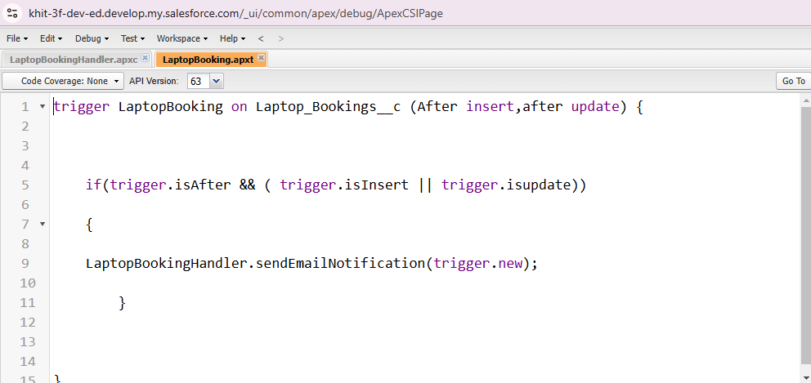

**Trigger Handler**:

How to create a new trigger :

1. While still in the trailhead account, navigate to the gear icon in the top right corner.
2. Click on developer console and you will be navigated to a new console window.
3. Click on File menu in the tool bar, and click on new? Trigger.
4. Enter the trigger name and the object to be triggered.
5. Name  :LaptopBooking
6. sObject :Booking __c

Syntax For creating trigger :

The syntax for creating trigger is :

Trigger [trigger name] on [object name]( Before/After event)

{

}

In this project , trigger is called whenever the particular records sum exceed the threshold i.e minimum business requirement value. Then the code in the trigger will get executed.

1. Handler for the Laptop Booking Object

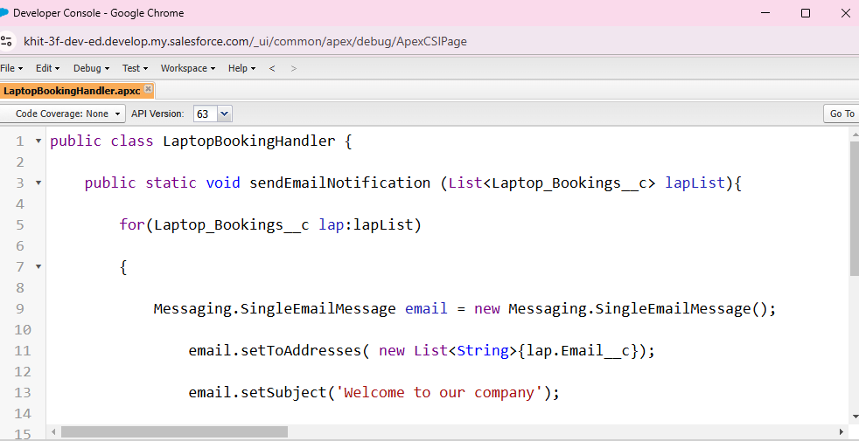

**Milestone 15 :**Reports

**create a report folder** :

1. Click on the app launcher and search for reports.
2. Click on the report tab, click on new folder.
3. Give the Folder label as “Laptop Rentals Folder”, Folder unique name will be auto populated.
4. Click save.

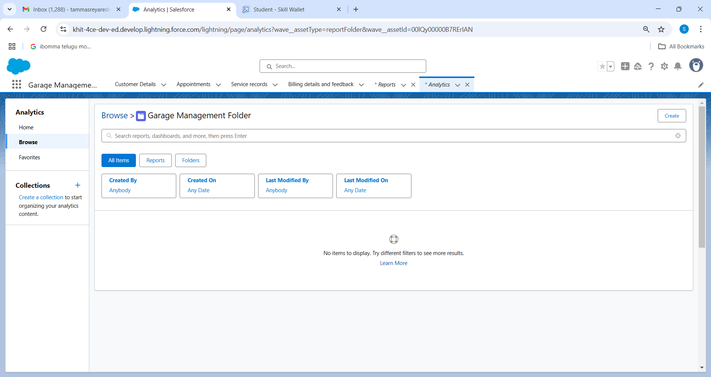

**Sharing a report folder :**

1. Go to the app  >> click on the reports tab.
2. Click on the All folder , click on the Drop down arrow for Laptop Rentals folder, and Click on share.
3. Select the share with as “another Person”, in name field search for “Owner”, give “Agent” as access for that role.
4. Then click share, and click on Done.

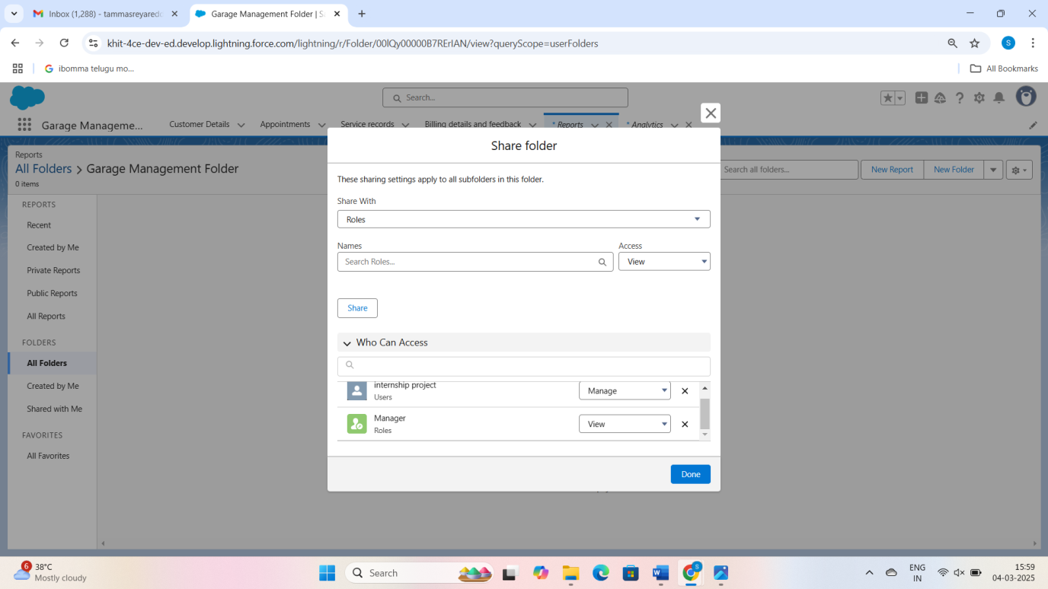

**Create Report Type**

1. Go to setup  >>  type users in quick find box  >>  select Report Type >> click on Continue.
2. Click on new custom report type.
3. Select the Primary object as “ Consumer details” .
4. Give the Report type Label as  “ Total Laptops”
5. Report type Name is autopopulated.
6. Keep the Description as same.
7. Select Store in Category as “ other Reports ”
8. Select the deployment status as “ Depolyed ”, click on Next.
9. now , Click on Related object box.
10. Click on Select Object, choose Laptop Booking Object as shown in fig.
11. Again Click to relate another object.
12. And select the related object as “ Total Laptops”.
13. Repeat the process and select the related object as “ Billing Process”.
14. And click on save.

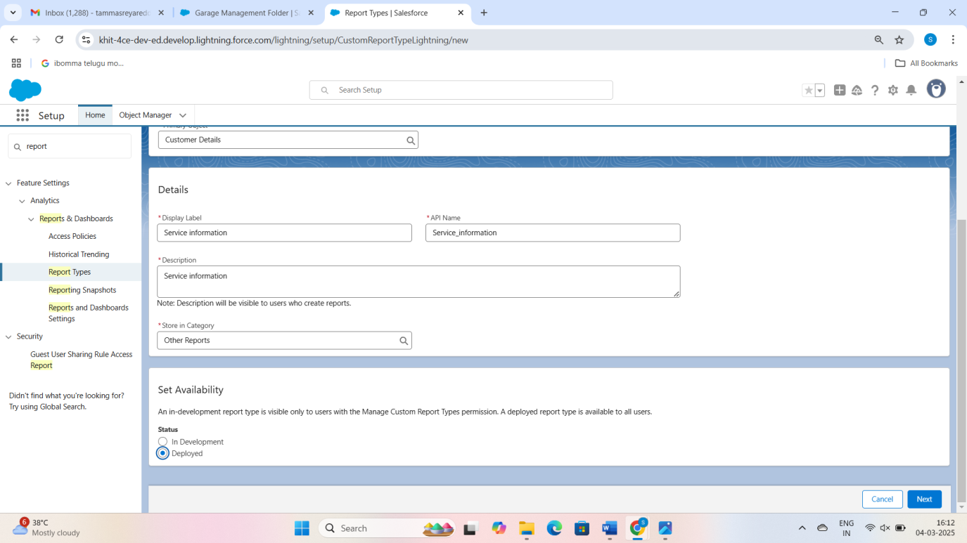

**Create Report**

Note : Before creating report, create latest “10” records in every object.

Try to fill every field in each record for better experience.

* 1. Go to the app  >>  click on the reports tab
  2. Click New Report.
  3. Select the Category as other reports, search for Service Information, select that report, click on it. And click on start report.

1. Create a simple tabular report
2. Add fields from left pane, make sure that Amount field will be selected.
3. Click the Amount column drop down and select bucket list

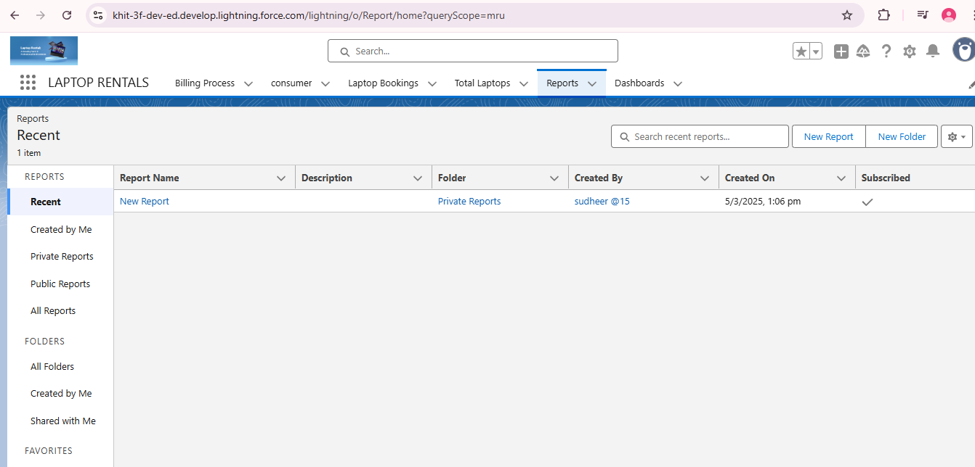

**Milestone16** :Dashboard

**Create Dashboard Folder :**

1. Click on the app launcher and search for dashboard.
2. Click on dashboard tab.
3. Click new folder, give the folder label as “ Service Rating dashboard”.
4. Folder unique name will be auto populated.
5. Click save.
6. Follow the same steps, from Reports Milestone and Activity 2, and provide the sharing settings for the folder that was just created.

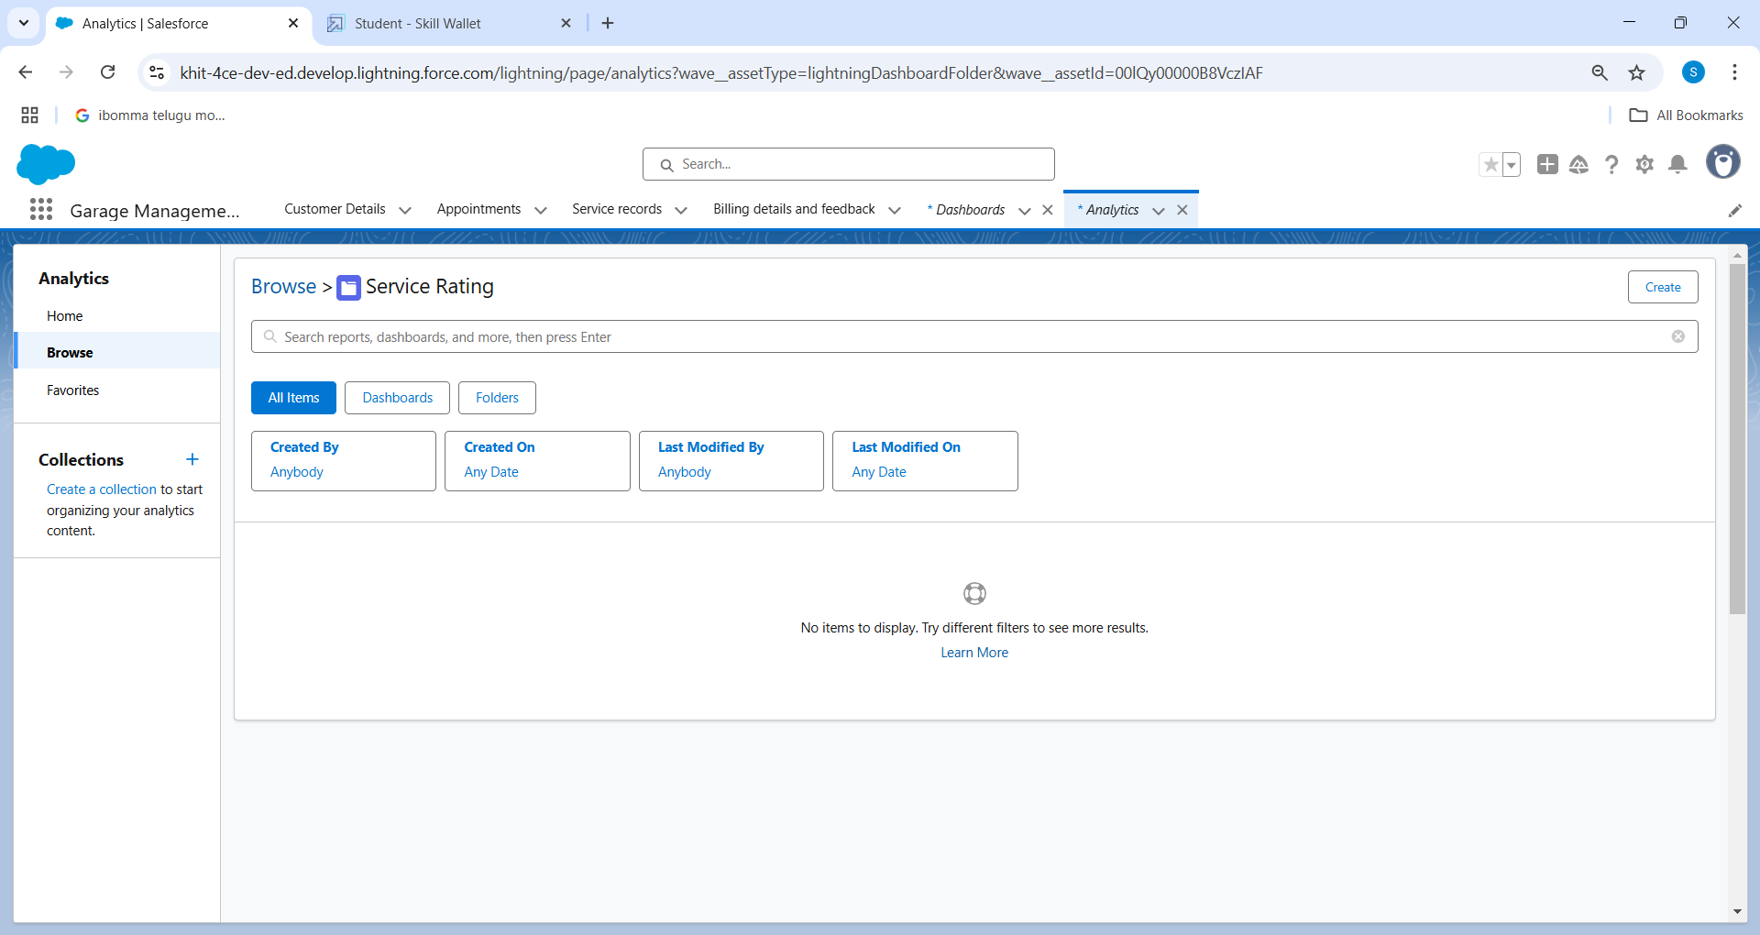

**Create Dashboard**

1. Go to the app >>  click on the Dashboards tabs.
2. Give a Name and select the folder that created, and click on create.
3. Select add component.
4. Select a Report and click on select.
5. Select the Line Chart. Change the theme.
6. Click Add then click on Save and then click on Done.
7. Preview is shown below.
8. After that Click on Subcribe on top right.
9. Set the Frequency as “ weekly ”.
10. Set a day as monday.
11. And Click on save.

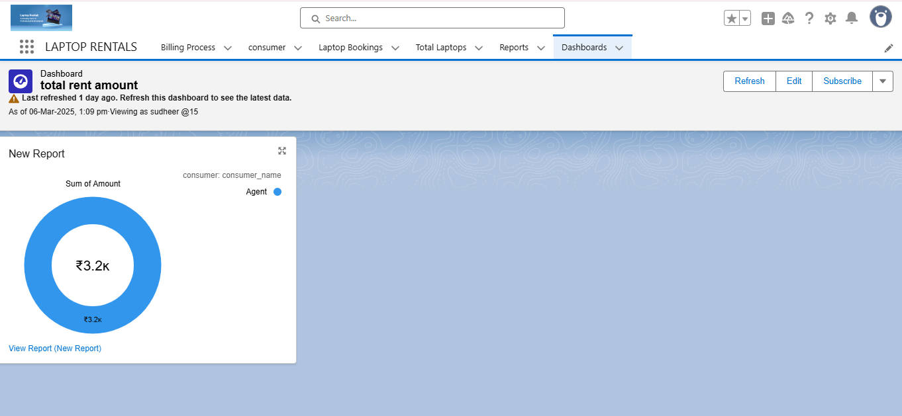

Conclusion:-

The CRM application for laptop rentals developed through Salesforce has successfully addressed the core requirements of managing rental operations efficiently. By leveraging Salesforce's powerful tools, we were able to streamline the entire rental process—from customer inquiries and contract management to invoicing and payment tracking. The implementation of automation features, such as reminders for rental due dates and automated invoicing, ensures that the workflow remains smooth and reduces manual intervention.

Through robust customer relationship management, the application enhances communication and provides a 360-degree view of the customer, helping to tailor services and improve customer satisfaction. Additionally, the reporting and analytics features allow for informed decision-making, giving insights into inventory utilization, rental trends, and customer behavior.

Overall, the CRM application for laptop rentals via Salesforce has proven to be an effective solution for optimizing operations, improving customer engagement, and ensuring the business remains competitive and efficient in the growing rental market. The system is scalable and flexible, with the potential to accommodate future business needs and expansion.